
CASTLE PRIMARY SCHOOL
Quick guide: Writing Sequences
The Approach:
Our teaching sequences ensure coverage of the following:
- something worth discussing;
- rich language to explore;
- national curriculum age-related structures (text and grammatical) that can be replicated to inspire pupils' original compositions.
Each teaching sequence is based around a core text, and follows a three part structure: Learning About the Text, Practising Writing and Independent Writing.
The EY curriculum is delivered through the use of Drawing Club.
Key principles
-High quality authentic texts as models for writing
-Scaffolded move to independence (three-part sequence)
-Writing needs to be explicitly taught and modelled
-Grammar in context
-Children have as much choice about their independent outcomes as possible
-Teachers need to adapt and personalise sequences, using the writing curriculum progression to ensure all objectives are covered over the year.
-Know how the model text ‘works’
-Know pupils’ starting points and needs
-Be very clear about outcomes and priorities from the outset
-Make informed decisions when adapting the sequence
-Use AfL throughout to ‘fine-tune’ teaching.
Key points:
Planning process | The clearer you are about where you want to go, the better chance you have of getting there…Backwards design is about striving for excessive clarity about what you want your students to be able to do’ Lean Lesson Planning: a practical approach to doing less and achieving more in the classroom (Peps Mccrea)  The teacher must know each chosen text well and complete a writerly knowledge chart to understand how it can be used most effectively to teach writing.  What’s the potential of the text?  What is it essential that children notice about this writing?  What will be the key things they must learn to apply in order to write like this?  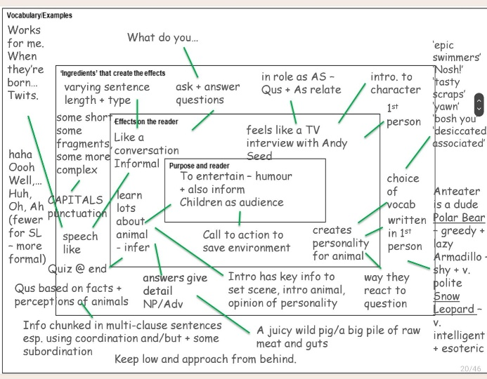
Three-part sequence | 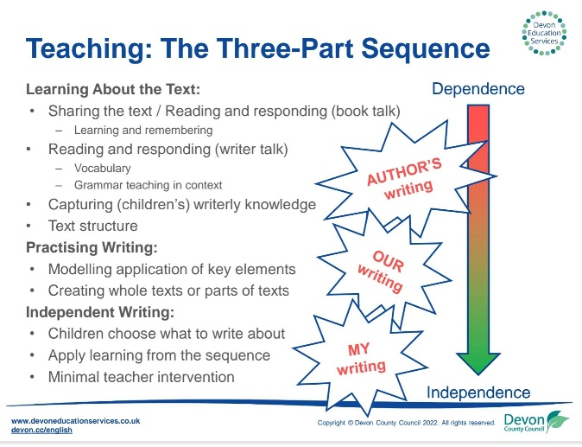
Each lesson will feature... | Retrieval task covering an element taught last week, last month and last year  A clear learning objective shared with the children  Core vocabulary  Opportunities for children to write (dependning upon th year group and stage of the writing sequence, this may be word level, sentence level or whole text level)
Elicitation | Completed using the Castle proforma which is clearly titled. Sequence planned from elicitation task and writerly knowledge chart. The elicitation task is completed with the children prior to the sequence starting.  What will interest my children?  What do my children need to demonstrate?  How will I support the generation of ideas?  What do pupils already know and can demonstrate?  What are the 2-3 biggest things that could transform their writing? What would be really disappointing for a child not to have grasped by the end of this unit?
Lesson delivery | Lessons typically start with a ‘Retrieval SPAG’ activity.  Main lesson:  Informed by the elicitation and ongoing assessment.  1. Learning the text  The purpose of this stage is to capture the children’s interest and help them get to know the text really well. This is through both ‘reading as a reader’ (exploring and sharing personal responses to what they read) and through ‘reading as a writer’ (recognising and investigating the features the writer uses to engage and manipulate the reader). It will often involve some form of learning and remembering of trickier or interesting sections to be used as an initial model for writing.  Each sequence will contain some or all of:  - a hook into the text  - reading and responding to the text  - comprehension activities  - retelling the text  - talking about the text  - in role in the text/drama  - vocabulary work  - analysing the text  - grammar in context  - identifying the structure of the text  2. Practising writing  During this stage, children try out the elements of writing they are less sure of so that they can use this experience when writing independently. Pupils have opportunities to play around with the language and structures they’ve been learning about and will be supported by their teacher.  In teaching sequences, this section usually includes:  - generating ideas to write about and one idea chosen  - a shared activity to generate content for the chosen content  - recording key ideas alongside the structure of the text  - telling and talk to generate the text  - story mapping the text where necessary  - Shared writing supports:  - Teacher modelling writing the text, usually in sections, applying learning from the first phase (through a range of methods – demonstration, joint construction and simultaneous drafting).  - children writing their own version of the text using the class idea  - editing writing  - proof-reading writing  3. Independent writing  Pupils plan and create an independent version of the text.  Each sequence is designed to build on children’s previous knowledge, as demonstrated through an elicitation task. Children are exposed to a range of genres and text types across the year so that they are able to write for a range of purposes and audiences. Previously taught literary techniques are revisited and embedded.
Assessment | - Gaps in learning identified from elicitation task  - Target set that is sharply pinpointing what the child needs most  - Target applies across curriculum  - Sequence plan and adapted over time  - Findings of Flashback grammar feeds into future Flashback sessions and in writing across the curriculum  - Regular moderation
Display | The writerly knowledge chart is a feature of each classroom, alongside key vocabulary, sentence constructions and the pupil’s work.
Talk Expectations | Castle ‘Talk Expectations’ referred to by the teacher and school stem sentences modelled and encouraged.  High expectations of all pupils to use specific vocabulary and full sentences to deepen understanding.  Sentence starters to be displayed, known and used regularly.
Marking Expectations | Marking policy followed which uses ‘green for great’ and ‘pink for think’.
Marking Expectations | Green highlighter to highlight example/s of where the pupil has demonstrated secure understanding. A comment may also be written to support this.
Marking Expectations | The teacher will also tick correct answers.
Marking Expectations | When appropriate, pupils may mark their own learning using a green pen.
Marking Expectations | Pink highlighter to highlight example/s of where the pupil has a misconception or needs to be stretched further. A comment may also be written to support this.

