Accessibility Plan 2025–2028
Castle Primary School
Approved by: | Castle Primary School Full Governing Body  School policy produced by Tom Paddon, Headteacher
Last reviewed on: | December 2025
Next review due by: | September 2026

Accessibility Plan 2025–2028
Contents
1. Aims
2. Legislation and guidance
3. Action plan
4. Monitoring arrangements
5. Links with other policies
6. Equality Objectives

1. Aims
Schools are required under the Equality Act 2010 to have an accessibility plan. The purpose of the plan is to:
1.increase the extent to which disabled pupils can participate in the curriculum
2.improve the physical environment of the school to enable disabled pupils to take better advantage of education, benefits, facilities and services provided
3. improve the availability of accessible information to disabled pupils
Our school aims to treat all its pupils fairly and with respect. This involves providing access and opportunities for all pupils without discrimination of any kind.
‘At Castle Primary School, our ultimate objective is that every child, regardless of need or background, is included, achieves and thrives. We want all pupils, including those with SEND and additional needs, to learn alongside their peers, to feel a strong sense of belonging, and to make the progress they are capable of. Inclusion is not the responsibility of a single member of staff; it is a whole-school commitment shared by leaders, teachers, support staff and governors.’ – Castle Primary School Inclusion Strategy
We believe that with the right teaching strategies and support, the great majority of children with Special Educational Needs and Disabilities (SEND) can be successfully included in mainstream education. The teaching and learning, achievements, attitudes and well-being of every pupil matter and should be valued in relation to their own potential, not the achievement of others.
This plan will be made available on the school website, and paper copies are available on request. Our school is committed to ensuring staff are trained in equality issues with reference to the Equality Act 2010, including understanding disability issues, and welcomes partnerships that support the development and delivery of this plan.
Our school's complaints procedure covers this accessibility plan. If you have any concerns relating to accessibility in school, that procedure sets out the process for raising them.
This plan has been developed with a range of stakeholders, including the SENDCo, staff and governors, and feedback received from pupils and parents that needs addressing.
2. Legislation and guidance
This document meets the requirements of schedule 10 of the Equality Act 2010 and the Department for Education (DfE) guidance for schools on the Equality Act 2010.
The Equality Act 2010 defines an individual as disabled if they have a physical or mental impairment that has a ‘substantial’ and ‘long-term’ adverse effect on their ability to undertake normal day-to-day activities.
Under the Special Educational Needs and Disability (SEND) Code of Practice, ‘long-term’ is defined as ‘a year or more’ and ‘substantial’ is defined as ‘more than minor or trivial’. The definition includes sensory impairments, such as those affecting sight or hearing, and long-term health conditions such as asthma, diabetes, epilepsy and cancer.
Schools are required to make ‘reasonable adjustments’ for pupils with disabilities under the Equality Act 2010, to alleviate any substantial disadvantage that a pupil with disabilities faces in comparison with a pupil without disabilities. This can include, for example, the provision of an auxiliary aid or adjustments to premises.

3. Action plan
This action plan sets out the aims of our accessibility plan in accordance with the Equality Act 2010. It includes objectives aligned to SIP priorities, with measurable actions and references to educational research.
Aim | Current good practice | Objectives | Actions to be taken | Person responsible | Date to complete actions by | Success criteria | Review
Increase access to the curriculum for pupils with a disability | OAIP principles introduced but not fully embedded; variation in adaptive teaching. | Embed OAIP strategies consistently across classrooms to support SEND and disadvantaged pupils (SIP Priority 5 & 2) | Deliver termly CPD on OAIP scaffolds linked to 'The Castle Way.' Phase leaders to monitor OAIP implementation during learning walks. SENDCo to provide coaching for staff needing additional support. | TP | CPD Autumn, Spring, Summer; monitoring half-termly. | Outcome: 100% of classrooms show evidence of OAIP strategies in planning and delivery. SEND pupils demonstrate progress in core subjects (10%+ from starting points). Success criteria: OAIP strategies observed in all classrooms; staff articulate impact confidently. Research: DfE's Inclusive Teaching Framework and Rosenshine's Principles highlight scaffolding and modelling as key to closing gaps. | Evidence seen in all classrooms of strategies. Published outcomes show strong improvement in MTC and Y6 SATs in particular.
Increase access to the curriculum for pupils with a disability | Writing attainment is low; SEND/EAL pupils face bariers. | Improve access to writing curriculum for pupils with SEND and EAL (SIP Priority 4 & 5) | Provide adapted BookWrites resources (visual scaffolds, sentence starters). Introduce bilingual support tools (e.g., translate app) for EAL pupils. TA-led small group writing interventions tracked via Provision Map. | TP & RWi | Autumn term adaptation; interventions ongoing. | Outcome: SEND/EAL pupils show measurable improvement in writing stamina and accuracy. At least 80% of targeted pupils meet intervention progress milestones. Success criteria: Book scrutiny evidences improved access and progress for SEND/EAL pupils. Research: EEF's Improving Literacy in KS2 recommends sentence-level scaffolds and oral rehearsal for EAL learners. | Writing stamina improvement seen across school. Practising writing for 26/27 will strengthen this further
Increase access to the curriculum for pupils with a disability | SALT wait times are long; phonics strong in EYFS/KS1 but gaps persist in KS2. | Prioritise speech and language and phonics interventions for pupils with identified needs (SIP Priority 4 & 5) | Continue EYFS Language Link screening; introduce targeted speech groups across KS1/KS2. Embed phonics catch-up for KS2 pupils using RWI and precision teaching. Track impact via Provision Map and termly reviews. | AG | Autumn term launch; review termly. | Outcome: Pupils with SALT needs show measurable progress in expressive/receptive language. KS2 pupils below phonics threshold improve decoding and fluency. Success criteria: SALT and phonics interventions show progress in 80%+ of tracked pupils. Research: EEF's Oral Language Interventions and Phonics Guidance Report confirm strong impact on attainment when delivered systematically. | Phonics sustained strong results while SALT outcomes showed good progress for all pupils that took part.
Improve and maintain access to the physical environment | School environment accessible but lacks designated sensory areas for older pupils. | Ensure sensory-friendly space for KS2 pupils with SEMH and ASC needs (SIP Priority 5) | Repurpose one existing KS2 space as a sensory-friendly room with calming resources. Audit KS2 classrooms for sensory overload risks and provide simple mitigations (e.g., visual clutter reduction, noise-cancelling headphones). Delivered as a costed activity in our Inclusion Strategy 2026/27 (Universal, funded through core school budget). | AG | Room ready for Autmn term 2026; audit completed by end of Spring term with a view to developing space in Summer term. | Outcome: KS2 pupils with SEMH/ASC needs access sensory space daily as needed. Reduction in behavior incidents linked to sensory overload by 20%. Success criteria: Sensory space in use; monitoring shows positive impact on engagement and regulation. Research: EEF's Social and Emotional Learning guidance and CASEL framework stress safe spaces for emotional regulation. | Sensory space developed in KS2 and being used. Pupils who use it regulating better.
Improve the delivery of information to pupils with a disability | There is variation across the school with the use of resources to support pupils with communication needs. | To ensure staff adapt the delivery of information through the use of a range of communication methods and resources tailored to meet their individual needs (SIP Priority 5) | Develop whole school approach to supporting pupils with communication needs which includes a consistent use of inclusive classroom resources e.g. now/next, 'working towards', widgit | AG & TP | Autumn term adaptions and reviewed over the year. | Outcome: Through the use of consistent delivery, pupils understand tasks and expectations throughout the school day. Success criteria: Research: EEF research strongly supports the idea that children benefit from a range of communication methods tailored to their individual needs. The Education Endowment Foundation (EEF) highlights that communication and language approaches can add, on average, up to 7 months of additional progress for young children, especially when strategies are adapted to suit diverse needs. | Disadvantaged gap narrowing in most areas, particularly Maths. More focus needed in Wrting.

4. Monitoring arrangements
This document will be reviewed annually, alongside our Inclusion Strategy and Pupil Premium Strategy, but may be reviewed and updated more frequently if necessary.
It will be approved by the Full Governing Body.
5. Links with other policies
This accessibility plan is also linked to the following policies and documents:
4. School Improvement Plan
5. Inclusion Strategy 2026/27
6. Pupil Premium Strategy Statement 2025–2028
7. SEND policy
8.Equality information and objectives (public sector equality duty) statement for publication
9. Risk assessment policy
10. Health and safety policy
11 Supporting pupils with medical conditions policy
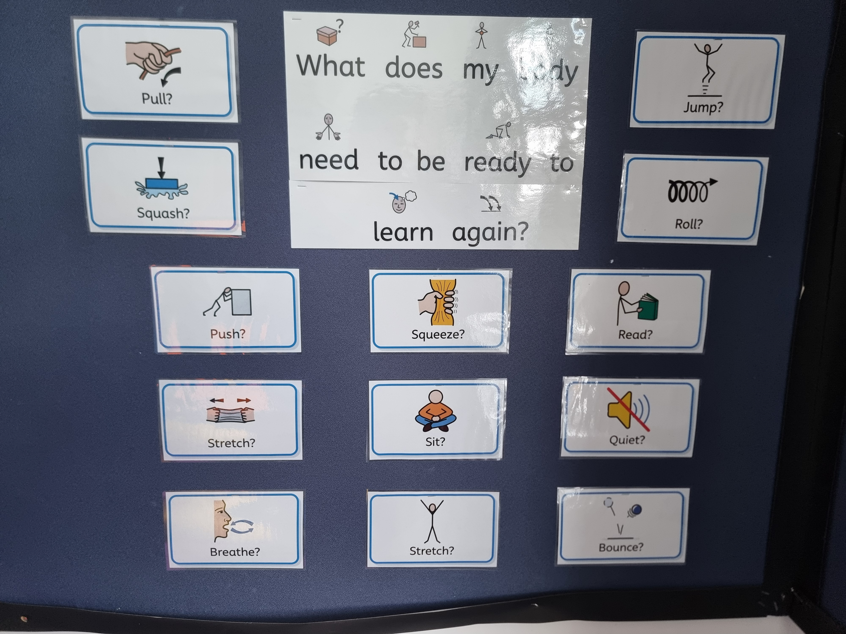
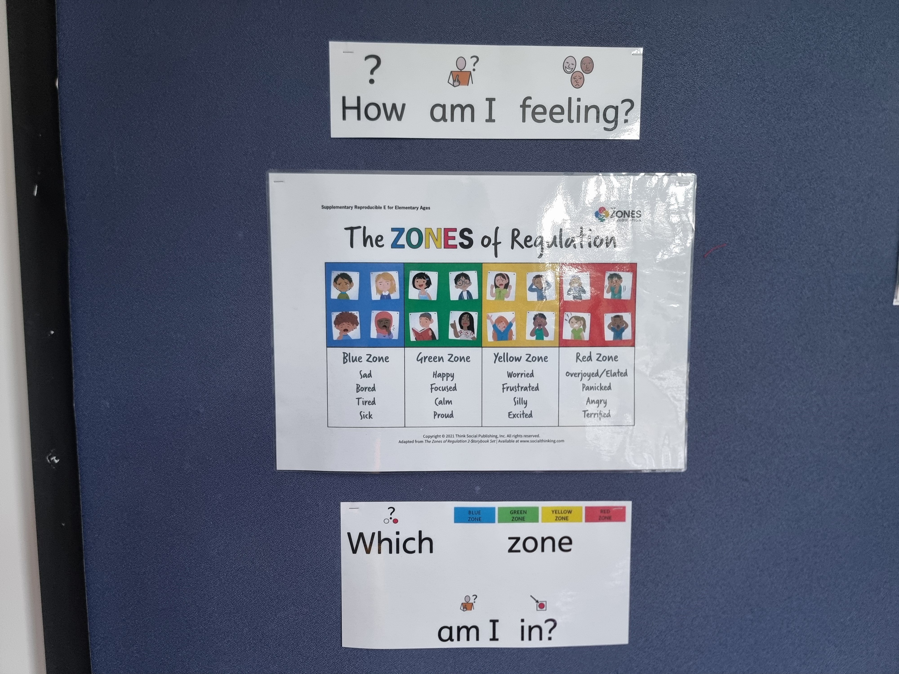
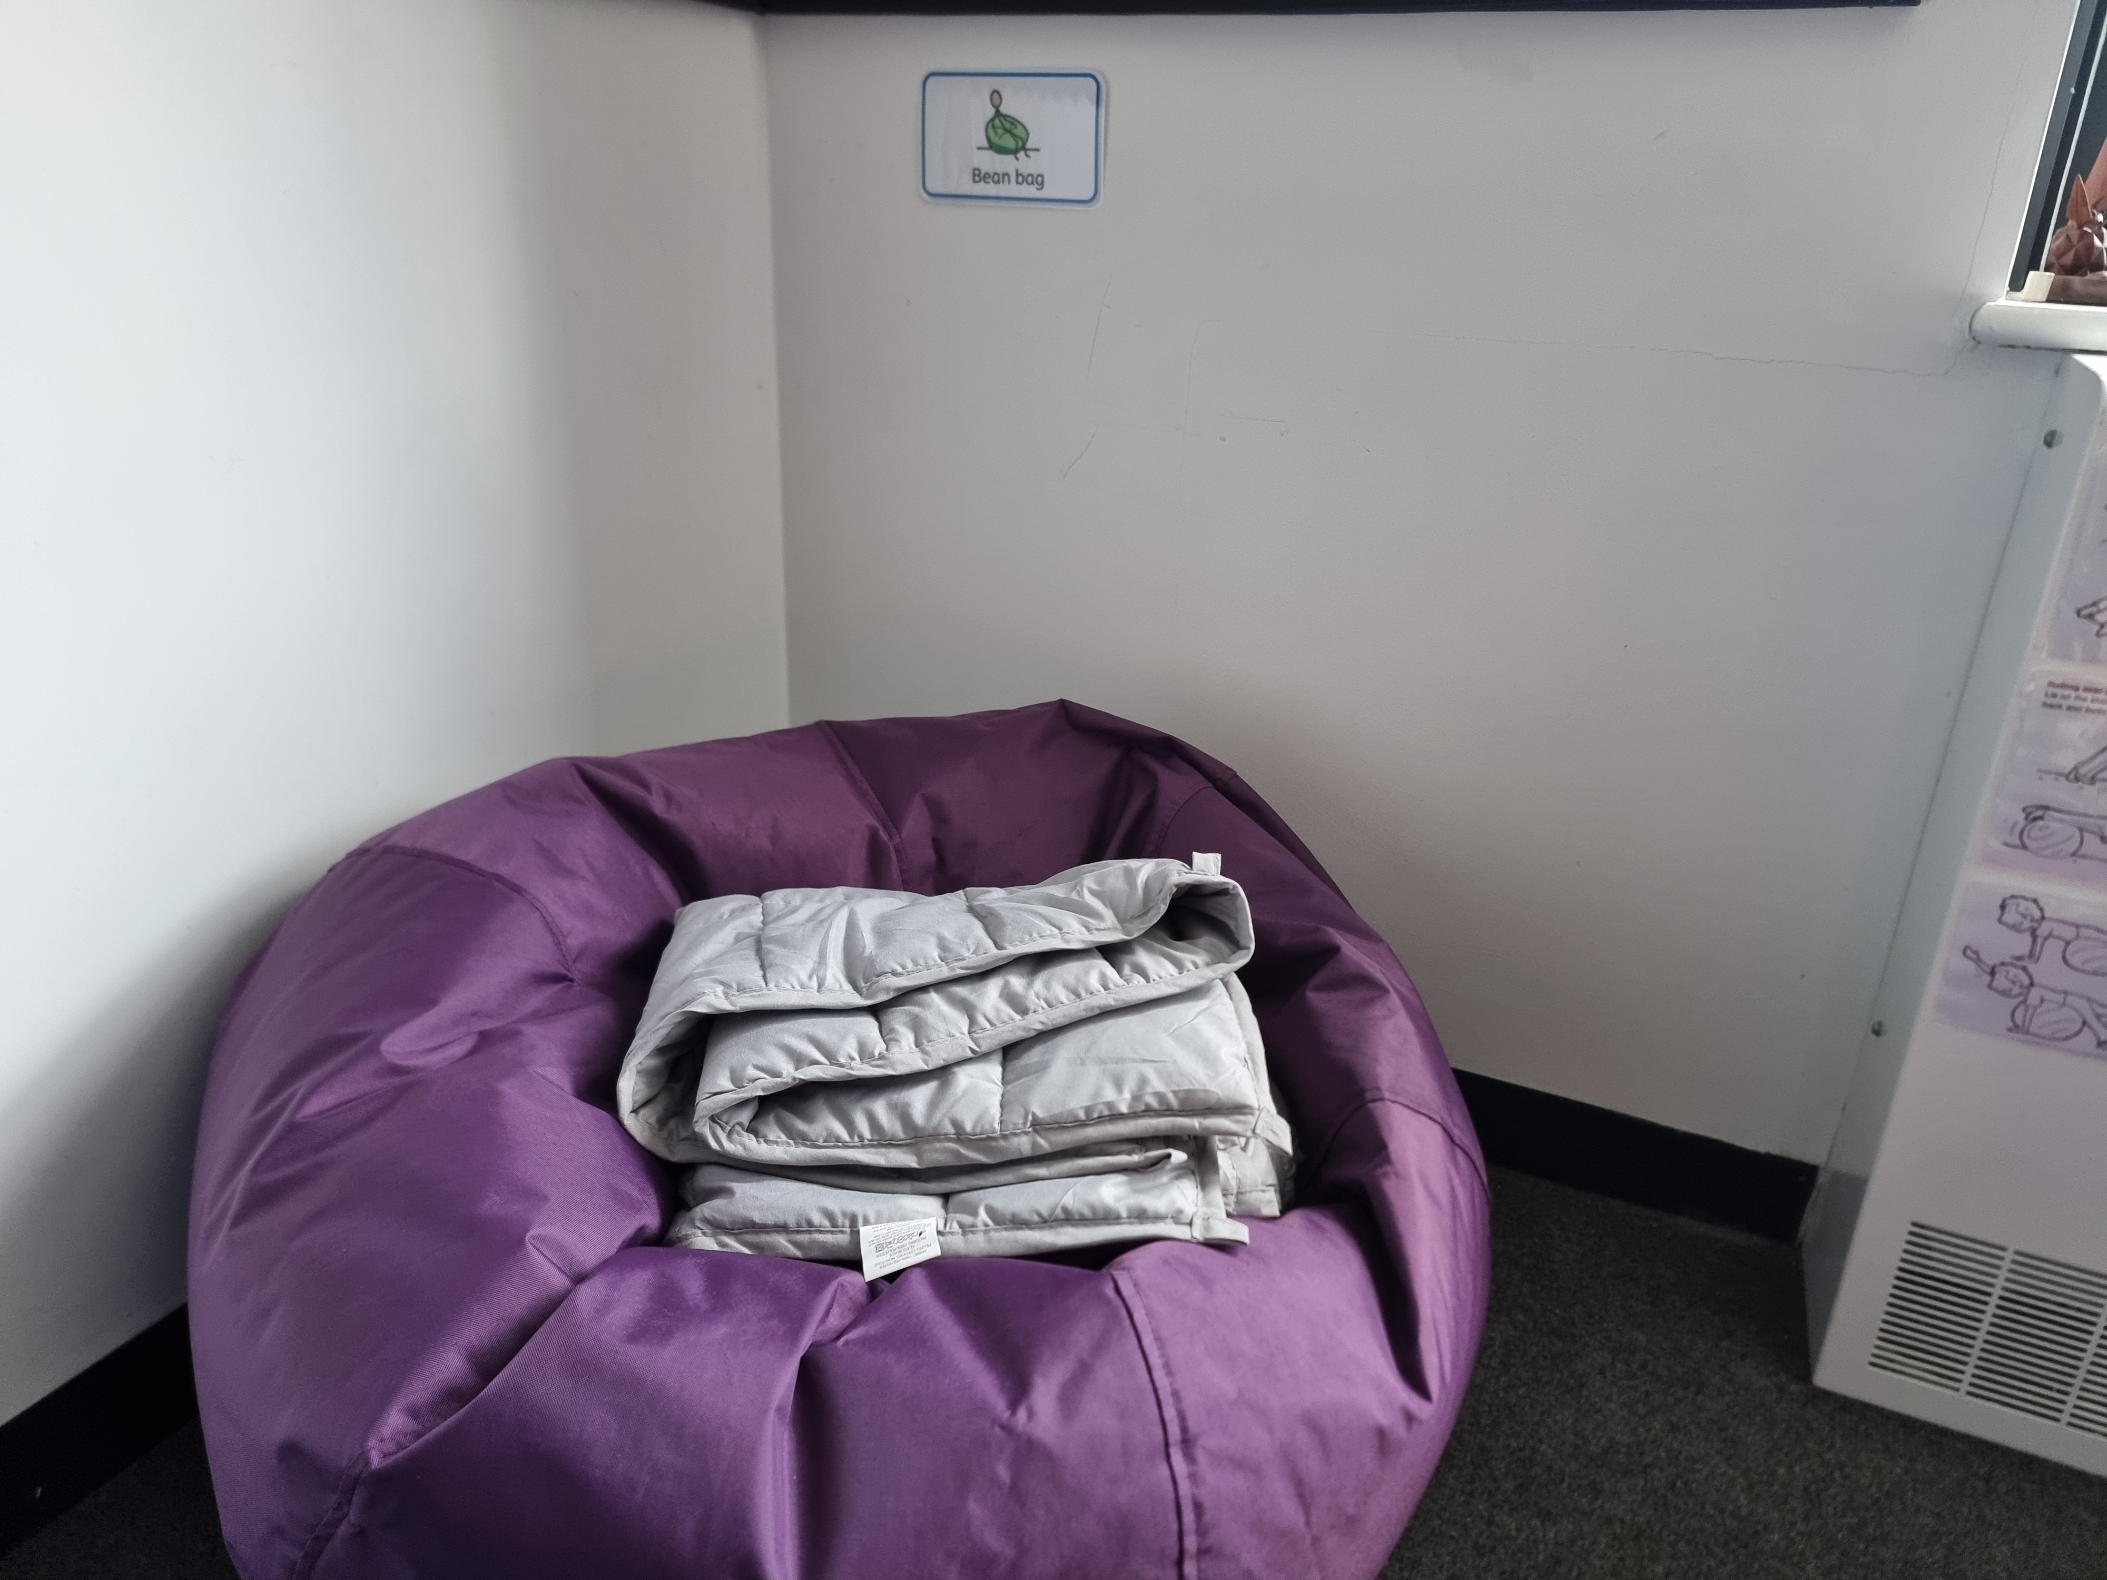
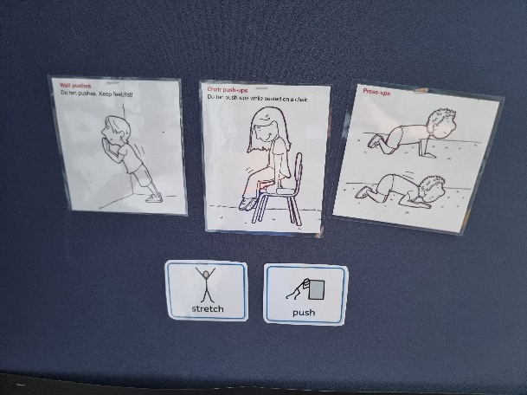
KS2 sensory space September 2026
